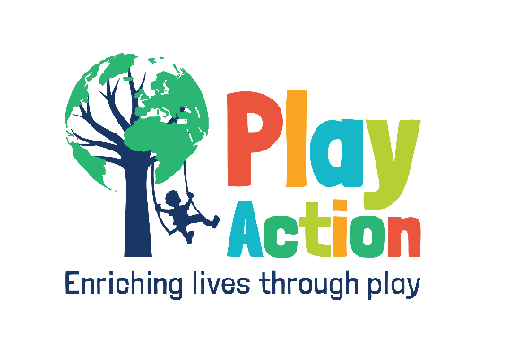
Anything But a Bag Day
Dear [insert headteacher’s/principal’s name],
I am approaching you as a previous student to your School/ Sixthform/ College, completing my studies in [insert year you finished at the school]. I am now at [insert your university or job]. This year, I have chosen to take on a fantastic volunteering opportunity in Uganda with the charity, Play Action International, where I will be building play and educational equipment for disadvantaged communities. Please see the charity’s attached Letter of Authority to confirm this. [insert how the institution has influenced you and talk about what you’re doing now]. In order to build this exciting playground, I have a fundraising target of £[insert your target] to reach.
Would [insert institution name] be interested in hosting an ‘Anything But A Bag’ Day in aid of Play Action International? Students would be encouraged to give a £1 donation to bring in hilarious bag alternatives. If you have not seen this before, here’s a great example: https://m.youtube.com/watch?v=hhdwz_BMi9w
Some good fun, right? I would suggest this instead of the traditional ‘Non-Uniform’ Day, and towards of the term. If you have a date in mind before the end of the academic year, please let me know. As a thank you I would like to offer you a few things back [insert whether you can be there in person, can give a presentation etc]. I also think such a unique day should be celebrated in the local papers if you would give me permission to contact them. This publicity would really make the institution shine, get word out about the charity and my fundraising, and be a nice happy story for the newspaper. A win-win for everyone!
How to register your institution for Anything But A Bag Day:
Head to https://playactioninternational.org/anything-but-a-bag-day/ where you can fill out a form to register. In the box labelled ‘How did you hear about the day?’ If you could mention my name, I would really appreciate that. This would mean the funds you submit will go towards the specific playground I will be building in Uganda in Summer 2022. Please note that my flights and other personal costs are NOT included in my fundraising target and will be self-funded. Please find my fundraising page here: [insert JG page]
On the link above there will be posters you can download to promote the day. Along with instructions on how to submit the donation after the day, and suggestions of hilarious bag alternatives – along with a few rules of course!
It would be great to discuss Anything But A Bag Day further, my volunteering and reminisce about my time at [insert institutions name] so please do get in contact with me using the details below. I would love to chat.
Thanks for your time. I look forward to hearing from you,
Yours sincerely,

[insert your name]
[your email/phone number]
Play Action International Volunteer
